**DAILY ONLINE ACTIVITIES SUMMARY**

|  |  |  |  |  |  |  |  |  |
| --- | --- | --- | --- | --- | --- | --- | --- | --- |
| **Date:** | **20-05-2020** | | | | | **Name:** | **Latika Kavoor** | |
| **Sem & Sec** | **4th Sem & A-Section** | | | | | **USN:** | **4AL18CS035** | |
| **Online Test Summary** | | | | | | | | |
| **Subject** | | **OOC** | | | | | | |
| **Max. Marks** | | **30** | | **Score** | | | **18** | |
| **Certification Course Summary** | | | | | | | | |
| **Course** | **Introduction to Cyber Security** | | | | | | | |
| **Certificate Provider** | | | **ICT Academy - CISCO** | | **Duration** | | | **30 hrs** |
| **Coding Challenges** | | | | | | | | |
| **Problem Statement:**1 Write a C or Java program to implement FCFS and SJF process scheduling. Input: Processes with burst time Output: Process being scheduled | | | | | | | | |
| **Status: Completed** | | | | | | | | |
| **Uploaded the report in Github** | | | | | **Yes** | | | |
| **If yes Repository name** | | | | | <https://github.com/Latika31/lockdown-coding> | | | |
| **Uploaded the report in slack** | | | | | **Yes** | | | |

Online Test Details: (Attach the snapshot and briefly write the report for the same)

Took the OOC test on 20-05-2020 from 9:25 to 10:10

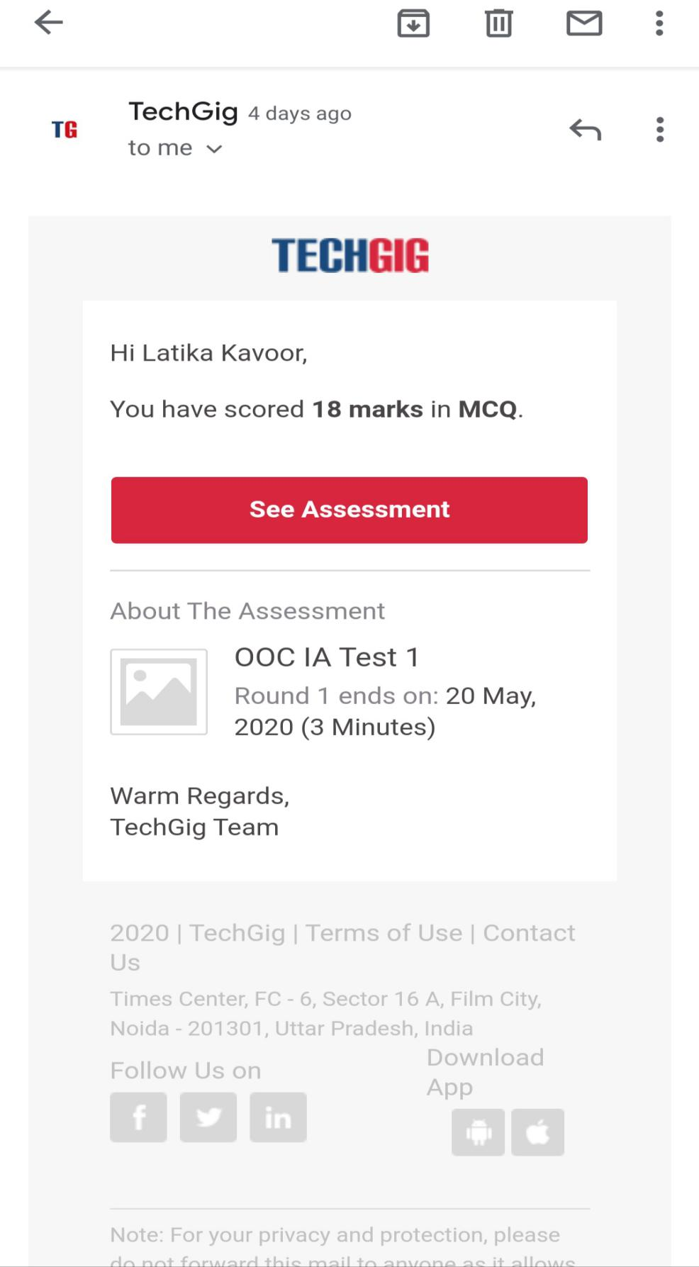

Certification Course Details: (Attach the snapshot and briefly write the report for the same)

Understood the concepts of Safegaurding our online policy

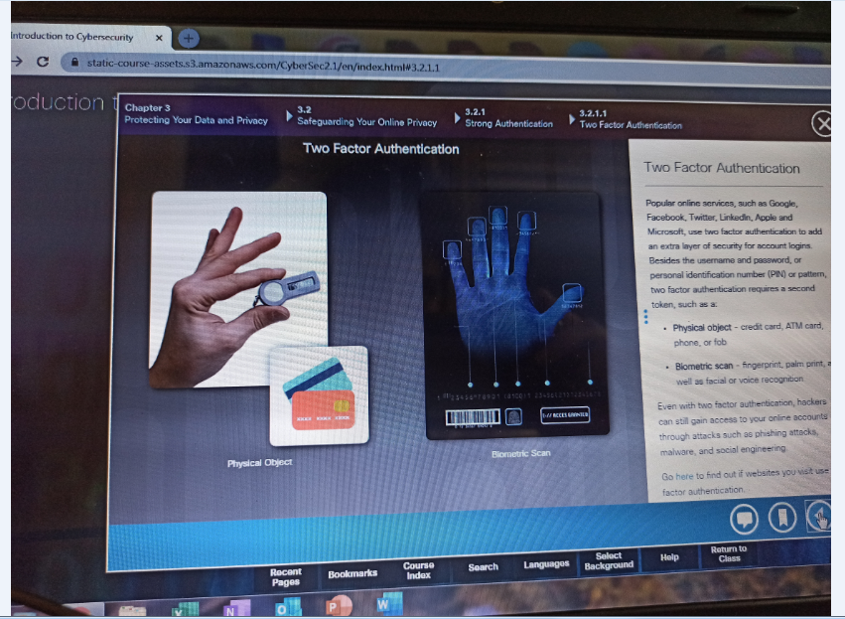

Coding Challenges Details: (Attach the snapshot and briefly write the report for the same) ---- Solved few problems and uploaded it on github